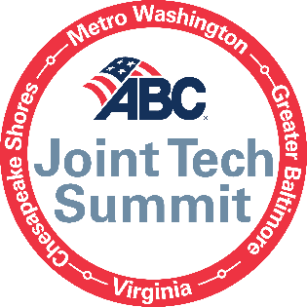
5 Key Takeaways for Each Session
Breakout ‘Tracks’ Block 1:
Project Manager/Superintendent Track: Building a Culture to Innovate (via Zulq)
- Innovation is not just buying technology – it’s a mindset.
- Creating a culture to innovate also assist with adoption / buy-in
- Some of the greatest innovations come from the field! How to engage your field operations.
- Promoting a culture to innovate and what it means to the next gen of workers.
- Innovations that have taken hold since COVID and the opportunities that have been untapped!

Safety Track: How Data Artificial Intelligence Improves Safety on the Jobsites

Executive/C-Suite Track: Intersection Between Technology and Construction with Kelly Schulz

Breakout ‘Tracks’ Block 2:
Project Manager/Superintendent Track: Getting the ROI on Your Tech

Safety Track: Jobsite Safety Technology
- The “best” software or app on the market might not be the right one for your company – before buying you need to understand your existing infrastructure and processes.
- Safety tech should effectively automate administrative duties, enabling you to focus time and talent on high-risk activities.
- Use the data to drive a real-time dashboard so people can get a sense of how they are doing and make adjustments.
- Don’t limit yourself to software, safety technology includes better processes and tools that eliminate physical hazards too.
- Effective Implementation = innovative technology + significant planning + effort + end-user education + ongoing support.

Executive/C-Suite Track: How Technology is Addressing the Labor Shortage (via Ronnie)
- Know when to hire and what role, bringing visibility to “real” capacity.
- Labor supply/demand balancing to manage “bench time”/unbillable time.
- Sourcing strategies using technology platforms (i.e., LinkedIn).
- Understand what is working through data; retention, turnover, fit…
- Ability to measure how well the talent acquisition process is performing.

