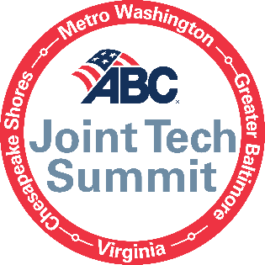
5 Key Takeaways for Each Session
Breakout ‘Tracks’ Block 1:
Project Manager/Superintendent Track: Building a Culture to Innovate (via Zulq)
- Innovation is not just buying technology – it’s a mindset.
- Creating a culture to innovate also assist with adoption / buy-in
- Some of the greatest innovations come from the field! How to engage your field operations.
- Promoting a culture to innovate and what it means to the next gen of workers.
- Innovations that have taken hold since COVID and the opportunities that have been untapped!

Safety Track: How Data Artificial Intelligence Improves Safety on the Jobsites

Executive/C-Suite Track: Intersection Between Technology and Construction with Kelly Schulz
- Every industry is becoming a technology-centric industry. Technology is increasingly becoming the backbone of every industry.
- Technology is fundamentally changing how construction companies deliver projects, from progress reporting and subcontractor management to worker safety and risk mitigation. The companies that ignore this shift risk getting left behind.
- Every industry - including construction and technology - needs a unifying voice to serve as its advocate. The Maryland Tech Council plays that role for the tech industry and ABC plays that role for the construction industry. Whether its workforce development or regulatory environment, policymakers are unlikely to understand your interests without consistent advocacy.
- Construction may not seem like an obvious target for cyber criminals, but if you have an internet connection you are a target. Most victims of cybercrime are small businesses that didn't invest in cyber security.
- Tech and construction share a common interest in workforce development. Both industries have a demand for talent that doesn't necessarily have advanced degrees. We must focus on hiring for skill, not just for degrees.
Breakout ‘Tracks’ Block 2:
Project Manager/Superintendent Track: Getting the ROI on Your Tech
- Understand why most companies are barely using the technology they have.
- Learn best practices to gain more out of technology.
- Discover the keys to selecting new technology.
- Calculate costs of technology vs process in effectiveness.
- Establish a process improvement through tech culture in your organization.

Safety Track: Jobsite Safety Technology
- The “best” software or app on the market might not be the right one for your company – before buying you need to understand your existing infrastructure and processes.
- Safety tech should effectively automate administrative duties, enabling you to focus time and talent on high-risk activities.
- Use the data to drive a real-time dashboard so people can get a sense of how they are doing and adjust.
- Don’t limit yourself to software, safety technology includes better processes and tools that eliminate physical hazards too.
- Effective Implementation = innovative technology + significant planning + effort + end-user education + ongoing support.

Executive/C-Suite Track: How Technology is Addressing the Labor Shortage (via Ronnie)
- Know when to hire and what role, bringing visibility to “real” capacity.
- Labor supply/demand balancing to manage “bench time”/unbillable time.
- Sourcing strategies using technology platforms (i.e., LinkedIn).
- Understand what is working through data; retention, turnover, fit…
- Ability to measure how well the talent acquisition process is performing.

